Muhammad Umar Farooq
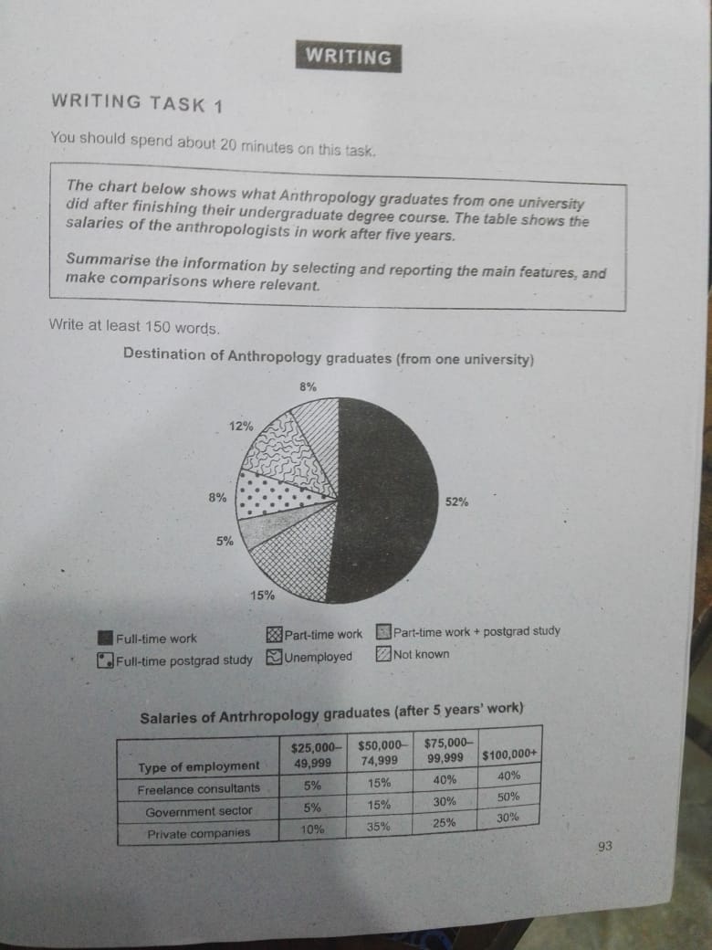
The bar chart illustrates the career paths of Anthropology graduates from a university, while the table shows their salary distribution after five years of employment in their respective fields.
Overall, the majority of Anthropology graduates were employed full-time, and both government and freelance positions offered higher salaries after five years compared to private sector jobs.
According to the chart, 52% of graduates secured full-time employment, while 15% worked part-time. About 12% were unemployed, and 8% chose to pursue further studies. Another 5% were combining part-time work with postgraduate study. A small proportion, 8%, did not provide information about their status.
The table shows that freelance consultants and government sector employees had similar salary distributions. In both groups, 40–50% earned more than $100,000 annually after five years, and a further 30–40% earned between $75,000 and $99,999. In contrast, only 30% of private sector employees earned over $100,000, while a larger portion (35%) earned between $50,000 and $74,999 over the time period.

